Motion - 02
CLASS 09 - SCIENCE

 | Section A
1 | What do you understand by a uniform velocity? | [1]
2 | What is negative acceleration? | [1]
3 | Define the term "velocity". | [1]
4 | What is the quantity which is measured by the area occupied below the velocity time graph? | [1]
5 | Which of the following is true for displacement?  - It cannot be zero.  - Its magnitude is greater than the distance traveled by the object. | [1]
6 | What is the nature of the displacement time graph of a body moving with constant acceleration? | [1]
7 | Can the speed of a body be negative? | [1]
8 | When is an object in motion considered to be a point object? | [1]
9 | Define average velocity. | [1]
10 | An object travels 16 m in 4 s and then another 16 m in 2 s. What is the average speed of the object? | [1]
11 | A plane has a take off speed of 88.3 m/s and requires 1365 m to reach that speed. Determine the acceleration of the plane and the time required to reach this speed. | [1]
12 | What is the relation between linear velocity and angular velocity? | [1]
13 | What is essential to describe the position of an object? | [1]
14 | What is the nature of the displacement time graph of a body moving with constant velocity? | [1]
15 | Under what condition will the displacement and distance have the same magnitude? | [1]
16 | The reference point from which the distance of a body is measured is called? | [1]
17 | What is the quantity which is measured by the area occupied below the velocity - time graph? | [1]
18 | Define acceleration of a body. | [1]
19 | What does the path of an object look likewhen it is in uniform motion? | [1]
20 | What does the odometer of an automobile measure? | [1]
21 | Give an example of non - uniform acceleration? | [1]
22 | When is the acceleration taken as negative? | [1]
23 | What do you mean by positive acceleration? | [1]
24 | State SI unit of acceleration. | [1]
25 | What is a reference point? | [1]
26 | The velocity of a body in motion is recorded every second as shown - 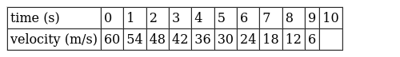  Calculate the -  - acceleration  - distance travelled and draw the graph. | [3]
27 | An electron moving with a velocity of 5$×$ 10 $​^{4}$ ms $​^{−1}$ enters into a uniform electric field and acquires a uniform acceleration of 10 $​^{4}$ ms $​^{−2}$ in the direction of its initial motion.  - Calculate the time in which the electron would acquire a velocity double of its initial velocity.  - How much distance the electron would cover in this time? | [3]
28 | What type of motion is represented by the following graphs. 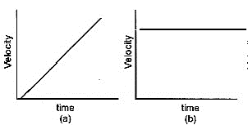  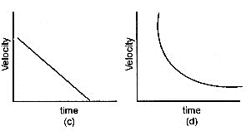 | [3]
29 | Starting from a stationary position, Rahul paddles his bicycle toattain a velocity of 6 ms$​^{−1}$ in 30 s. Then he applies brakes such that the velocity of the bicycle comes down to 4 ms $​^{−1}$ in the next 5 s. Calculate the acceleration of the bicycle in both cases. | [3]
30 | Two cars A and B are moving along a straight line. Car A is moving at a speed of 80 Km/h while car B is moving at a speed 50 Km/h in the same direction.Find the magnitude and direction of:(a) the relative velocity of car A with respect to B (b) The relative velocity of car B with respect to A. | [3]
31 | The position of a body at different times isrecorded in the table given below: - 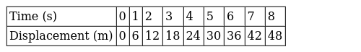  - Draw the displacement time graph for the above data.  - What is the slope of graph?  - What is the velocityof the motion? | [3]
32 | A body is dropped from a height of 320 m. The acceleration due to the gravity is 10 m/s$​^{2}$ . (a) How long does it take to reach the ground? (b) What is the velocity with which it will strike the ground? | [3]
33 | Draw the graph for uniform retardation -  - position - time graph  - velocity - time graph  - Acceleration - time graph | [3]
34 | Discuss the graphs A, B and C shown in the figure. Compare the total distance travelled and the displacements. Which graph represents a motion with negative acceleration? 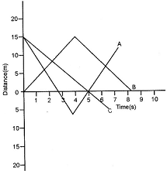 | [3]
35 | The velocity time graph of runner is given in the graph. 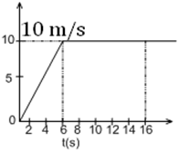  - What is the total distance covered by the runner in 16s?  - What is the acceleration of the runner at t = 11s? | [3]
36 | State which of the following situations are possible and give an example for each of these.(a) An object moving with a constant acceleration but with zero velocity (b) An object moving in a certain direction with an acceleration in the perpendicular direction. | [3]
37 | Write a short note on uniform circular motion. | [3]
38 | A cheetah is the fastest land animal and can achieve a peak velocity of 100 kmh$​^{−1}$ up to distances less than 500 m . If a cheetah spots his prey at a distance of 100 m, what is the minimum time it will take to get its prey, if the average velocity attained by it is 90 kmh $​^{−1}$ ? | [3]
39 | The driver of a car travelling along a straight road with a speed of 72 Km/h observes a signboard which give the speed limit to be 54 Km/h. The signboard is 70 m ahead, when the driver applies the brakes. Calculate the acceleration of the car which will cause the car to pass the signboard at the stated speed limit. | [3]
40 | Suppose you go up a tower 80 m high and throw a ball horizontally with a velocity of 20m/s. What will be the shape of the path followed by the ball? While falling, the motion of the ball will be a combination of two independent motions. Name these two motions. | [3]
41 | A stone is thrown in a vertically upward direction with a velocity of 5 ms$​^{−1}$ . If the acceleration of the stone during its motion is 10 ms $​^{−2}$ in the downward direction, what will be the height attained by the stone and how much time will it take to reach there? | [3]
42 | The speed - time graph for a car is shown is Fig. 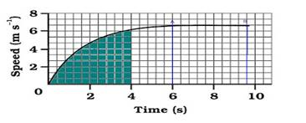  - Find how far does the car travel in the first 4 seconds?Shade the area on the graph that represents the distance travelled by the car during the period.  - Which part of the graph represents uniform motion of the car? | [3]
43 | The average time taken by a normal person to react to an emergency is one fifteenth of a second and is called the ’reaction time’. If a bus is moving with a velocity of 60 kmh$​^{−1}$ and its driver sees a child running across the road, how much distance would the bus had moved before he could press the brakes? The reaction time of the people increases when they are intoxicated. How much distance had the bus moved if the reaction time of the driver were 1/2 s under the influence of alcohol? | [3]
44 | A driver of a car travelling at 52 km h$​^{−1}$ applies the brakes and accelerates uniformly in the opposite direction. The car stops in 5 s. Another driver going at 3 km h $​^{−1}$ in another car applies his brakes slowly and stops in 10 s. On the same graph paper, plot the speed versus time graphs for the two cars. Which of the two cars travelled farther after the brakes were applied? | [3]
45 | An iron ball of density 7800 k gm$​^{−3}$ and volume 200 cm $​^{−3}$ is totally immersed in water.  - Calculate the weight of the iron ball in the air.  - Calculate the upthrust.  - Its apparent weight in water.  - Its apparent density in water. | [3]
46 | A particle moves in a circle with O as centre and AO = OB = 5 cm, radius, as shown in the figure. It starts from A. Calculate. 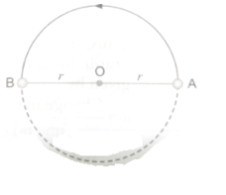  - the distance covered, and  - the displacement, when it reaches B. | [3]
47 | Two trains A and B of length 400 m each are moving on two parallel tracks with uniform speed of 72 kmh$​^{−1}$ in the same direction with A ahead of B. The driver of B decides to overtake A and accelerates by 1 ms $​^{−2}$ . If after 50s, the guard of B just passes the driver of A, what was the original distance between them? | [3]
48 | The graph given below shows the positions of a body at different times. Calculate the speed of the body as it moves from  - A to B  - B to C  - C to D 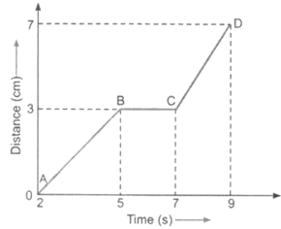 | [3]
49 | A train travels the first 15 km at a uniform speed of 30 kmh$​^{−1}$ , the next 75 km at a uniform speed of 50 kmh $​^{−1}$ , and the last 10 km at a uniform speed of 20 kmh $​^{−1}$ . Calculate the average speed for the entire train journey. | [3]
50 | Deduce the following equations of motion:  - S =ut +$\left(\frac{1}{2}\right)$ at $​^{2}$  - v$​^{2}$ = u $​^{2}$ + 2aS | [3]
51 | A train is travelling at a speed of 90 kmh$​^{−1}$ . Brakes are applied so as to produce a uniform retardation of 0.5 ms $​^{−2}$ . Find how far the train will go before it is brought to rest. | [3]
52 | Four cars A, B, C and D are moving on a leveled road. Their distance versus time graphs are shown in figure. Which car is the slowest. 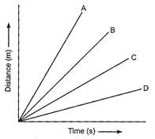 | [3]
53 | A bus starting from rest moves with a uniform acceleration of 0.1 m s$​^{−2}$ for 2 minutes. Find:  - the speed acquired.  - the distance travelled. | [3]
54 | A ball starts from rest and rolls down 16 m down an inclined plane in 4 s.(a) What is the acceleration of the ball? (b) What is the velocity of the ball at the bottom of the inclined plane? | [3]
55 | A girl walks along a straight path to drop a letter in the letterbox and comes back to her initial position. Her displacement–time graph is shown in Fig. Plot a velocity - time graph for the same. 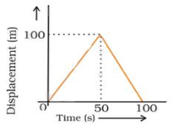 | [5]
56 | Derive the second equation of motion S= ut +at$​^{2}$ graphically? | [5]
57 | State with reasons, if it is possible or impossible for an object in motion to have:  - Zero distance covered and may have non zero displacements.  - Zero speed covered and may have non zero acceleration at the same time.  - Zero speed and may have non zero velocity.  - Acceleration opposite to the direction of motion. | [5]
58 | Soham is moving in his car with a velocity of 90 km/h. How much distance will be covered in  - One minute  - one second. | [5]
59 | The distance - time graph of the two trains isshown in the figure. The trains start simultaneously in the same direction.  - How much A is ahead of B when the motion starts?  - What is the speed of B?  - When and where will A catch B? 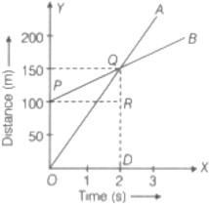  - What is the difference between speeds of A and B?  - Is the speed of both the trains uniform or non - uniform? Justify your answer. | [5]
60 | On a 100 km track, a train travels the first 30 km at a uniform speed of 30 km/h. How fast must the train travel the next 70 km, so as to average 40 km/h for the entire trip? | [5]
61 | The velocity - time graph of a body is shown in the following figure.Answer the following questions: 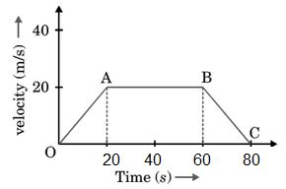  - State the kind of motion represented by OA and AB  - What is the velocity of the body after the 20s and after 80s?  - Calculate the negative acceleration of the body.  - Calculate the distance covered by the body between 20$​^{th}$ and 60 $​^{th}$ seconds. | [5]
62 | How will you show that the slope of the displacement - time graph gives the velocity of the body? | [5]
63 | Derive an equation for velocity - time relation by graphical method. | [5]
64 | Give one example of each of the following situations:  - Uniformly accelerated motion.  - Motion with uniform retardation.  - Accelerated motion with uniform magnitude of velocity.  - Motion in a direction with acceleration in perpendicular direction.  - Motion in which v - t graph is a horizontal line parallel to X - axis. | [5]
65 | A driver of a car travelling at 52 km h$​^{−1}$ applies the brakes and accelerates uniformly in the opposite direction. The car stops in 5s. Another driver going at 3 km h $​^{−1}$ in another car applies his brakes slowly and stops in 10s. On the same graph paper, plot the speed versus time graphs for the two cars. Which of the two cars travelled further after the brakes were applied? | [5]
66 | - What is the importance of a reference point?  - Is it possible that the train in which you are sitting appears to move while it is at rest?  - Odometer measures the displacement of the vehicle. Correct this statement.  - A particle is moving in a circular path of radius r. What will be the displacement after half a circle? 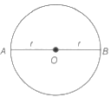  - In which condition, will the magnitude of the displacement be equal to the distance travelled by an object? | [5]
67 | - If the displacement ofa body is zero, is it necessary that the distance covered by it is also zero?  - A body starts to slide over a horizontal surface with an initial velocity of 0.7 m/s. due to friction, its velocity decreases at the rate 0.07 m/s$​^{2}$ . How much time will it take for the body to stop? | [5]
68 | Two stones are thrown vertically upwards simultaneously with their initial velocities u$​_{1}$ and u $​_{2}$ respectively. Prove that the heights reached by them would be in the ratio of $u_{1}^{2}$ : $u_{2}^{2}$ (Assume upward acceleration is - g and downward acceleration to be +g). | [5]
69 | - Define circular motion?  - An athlete completes one round of a circular track of diameter 200 m in 40 s. If he continues to run, what will be the distance covered and the displacement at the end of 2 minutes 20 s respectively? | [5]
70 | Draw a distance - time graph for an object moving with uniform and non - uniform speed. | [5]
71 | Two boys A and B, travel along the same path. The displacement - time graph for their journey is given in the following figure: 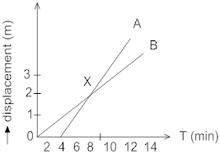  - How far down the road has B travelled when A starts the journey?  - Without calculation, the speed, state who is travelling faster A or B?  - What is the speed of A?  - What is the speed of B?  - Are the speed of A and B uniform?  - What dose point X on the graph represent?  - What is the speed of approach of A towards B?  - What is the speed of separation of A from B? | [5]
72 | An object starting from rest travels 20 m in the first 2 s and 160 m in the next 4 s. What will be the velocity after 7 s from the start? | [5]
73 | Using following data, draw time - displacement graph for a moving object: 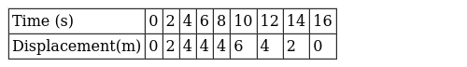  Use this graph to find average velocity for first 4s, for next 4s and for last 6s. | [5]
74 | 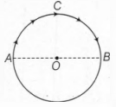  An insect moves along a circular path of radius 10 cm with a constant speed. It takes 1 min to move from a point on the path to the diametrically opposite point, find  - the distance covered,  - the speed,  - the displacement and  - the average velocity. | [5]
75 | The position - time graphs of two objects A and B in three different situations for a particular duration are shown as below: 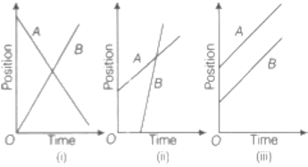  - In which situation the distance between them will remain same?  - In which situation they are moving in opposite directions?  - Is the velocity of object A positive or negative in situation (ii)?  - Are they crossing each other in any situation (s)? If so, why? | [5]

